**Open source intelligence project**

**OSINT (Open-source intelligence)**

OSINT Framework, as its name implies, is a cybersecurity framework, a collection of OSINT tools to make your intel and data collection tasks easier.

This tool is mostly used by security researchers and penetration testers for digital footprinting, OSINT research, intelligence gathering, and reconnaissance.

It provides a simple web-based interface that allows you to browse different [OSINT tools](https://securitytrails.com/blog/osint-tools) filtered by categories.

It also provides an excellent classification of all existing intel sources, making it a great resource for knowing what infosec areas you are neglecting to explore, or what will be the next suggested OSINT steps for your investigation.

OSINT Framework is classified based on different topics and goals. This can be easily seen while taking a look at the OSINT tree available through the web interface

**Tasks:**

**● Gathering basic organization information like name, address, and location from open sources tools and techniques.**

We can get the simple information by searching and surfing on internet through different techniques and search engines.

Target: <https://imarticus.org/>

Different types of result using different search engines

Duckduckgo :

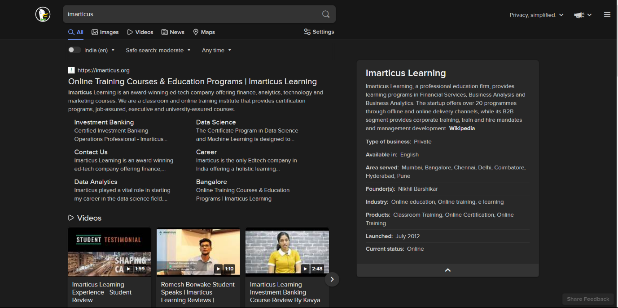

Google:

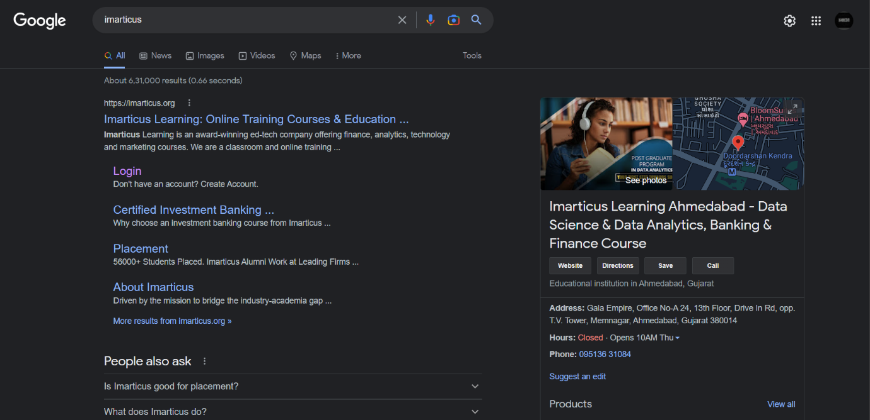

We can see here we get the simple and basic information using only one word search.

**●Gathering information from social media like Twitter Facebook Google Instagram Pinterest Reddit LinkedIn Snapchat WhatsApp Skype Telegram and dating sites and should be able to convert and connect it for making intelligent information.**

We can use different social media platforms for gathering information about organizations and employee.

**Linkedin:**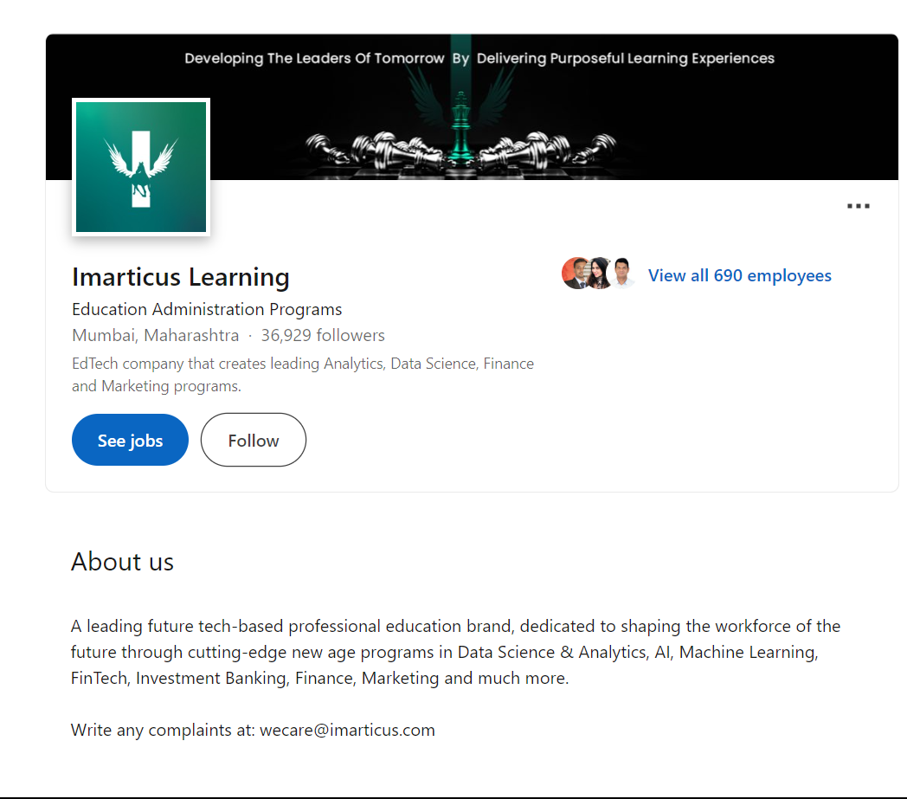 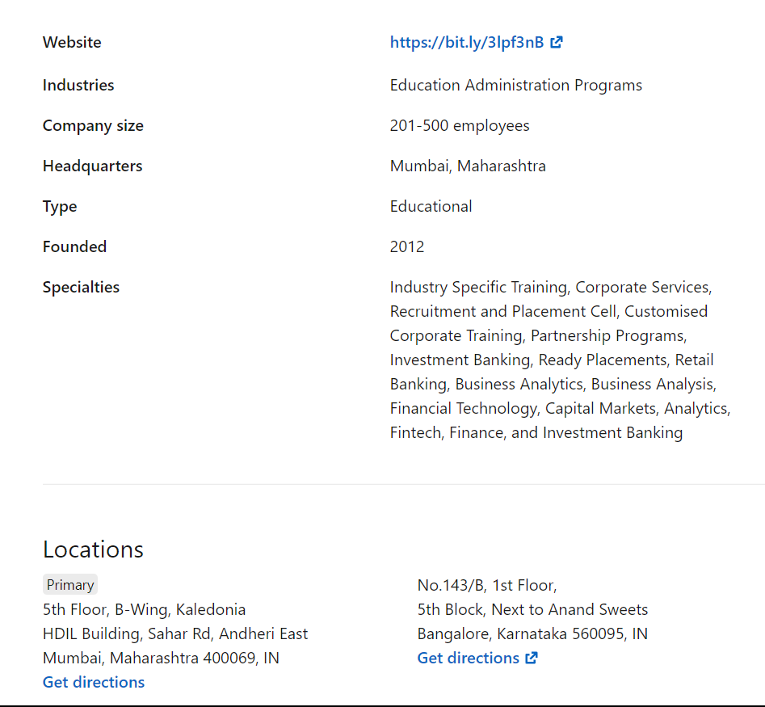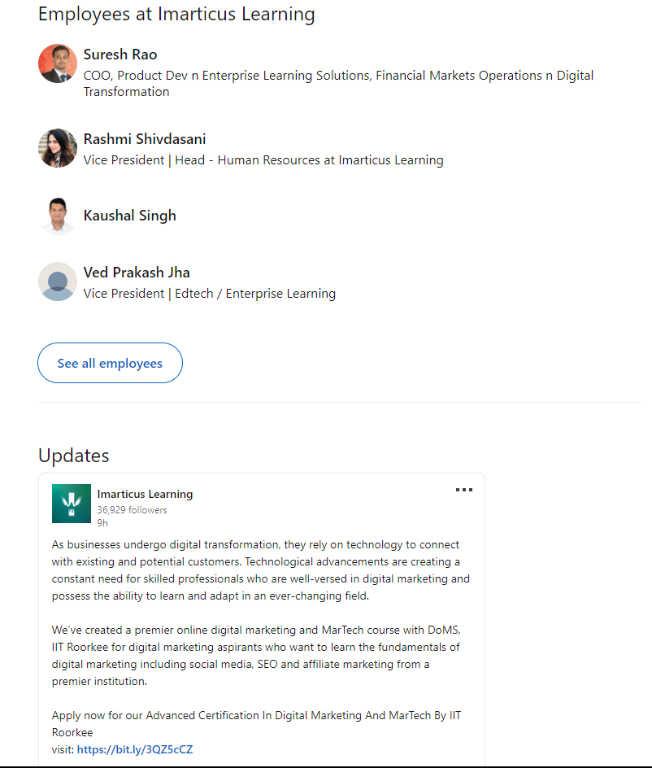

Here , we can see that through linkdein we get the information like about the organization’s ,total numbers of employees , some are the higher employee and authority persions,new updates,address,locations,on which organization work and many more.

We can get from linkedin there are total 690 employee’s and 36929 followers and founded on 2012

**Instagram:**

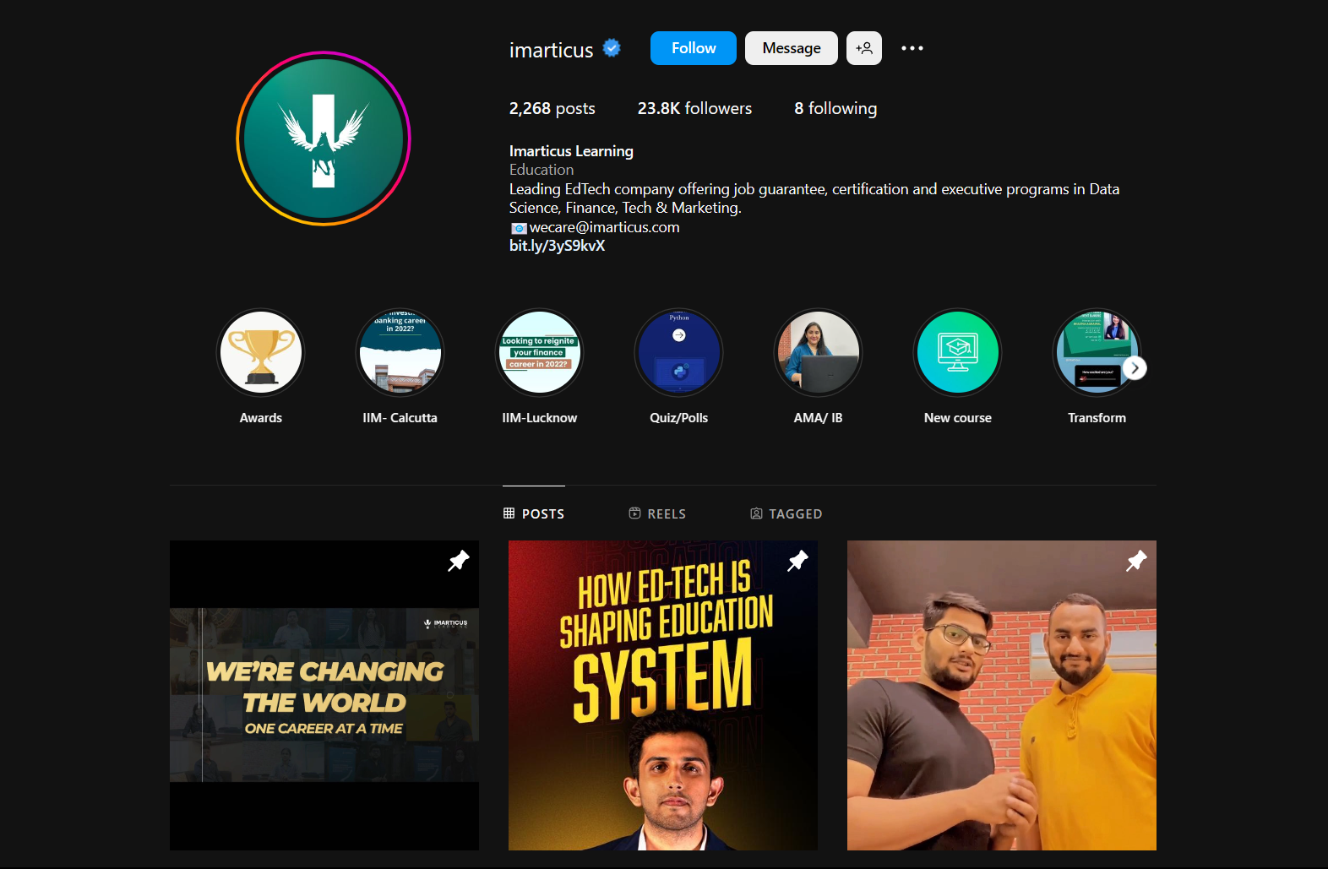

We can get information using Instagram through daily monitoring the profile’s, posts, story’s so we are aware and update on daily basis

Organization have posted 2268 posts and 23.8k followers , 8 following

**Facebook:**

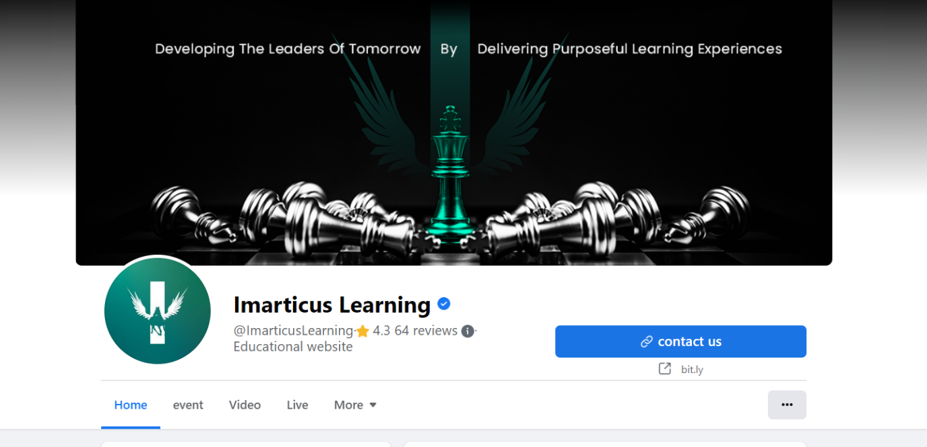

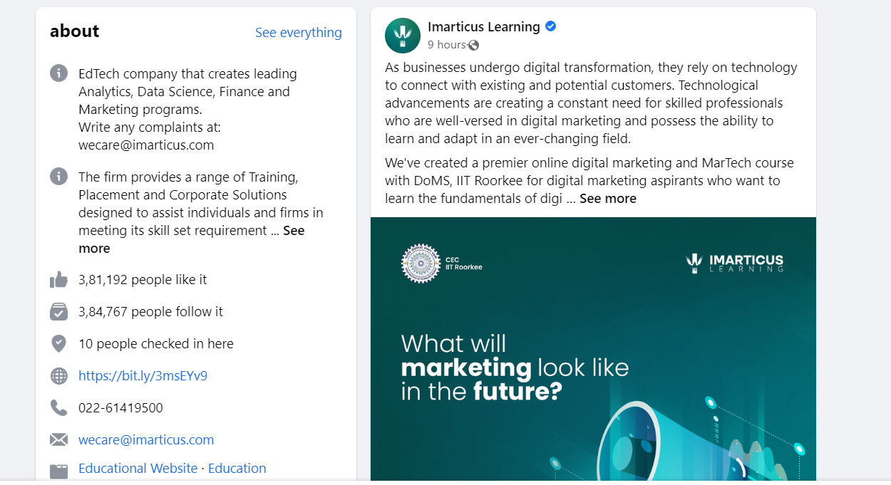

We can get information using Facebook through daily monitoring the profile’s, posts, story’s so we are aware and update on daily basis

Organization have 3,84,767 followers and 4.3 rating and 64 reviews

**Twitter:**

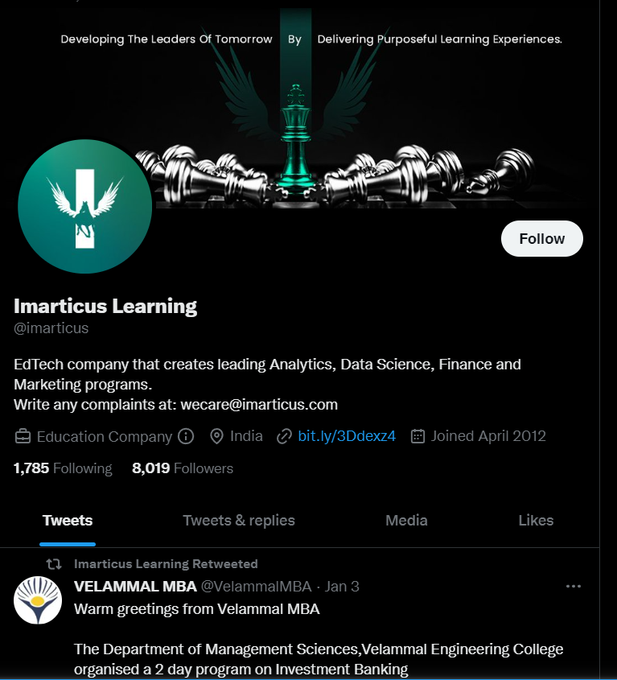

We can get information using Twitter through daily monitoring the profile’s ,tweets, posts, story’s so we are aware and update on daily basis

Organization have 1785 following and 8019 followers , joined in 2012 location:india , company:education company

**●Gathering Informations using organizations' websites, Blogs, Forums, Discussion Boards, and Q&A Sites.**

Organization websites and sub domains:

<https://imarticus.org/>

<https://imarticus.org/analytics/>

<https://corporate.imarticus.org/>

<https://blog.imarticus.org/why-choose-game-based-learning-imarticus-learning-explain/>

<https://imarticus.fourthambit.com/login>

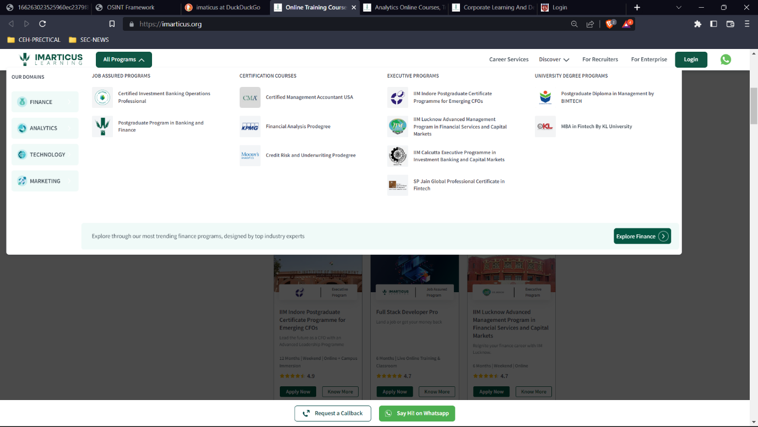

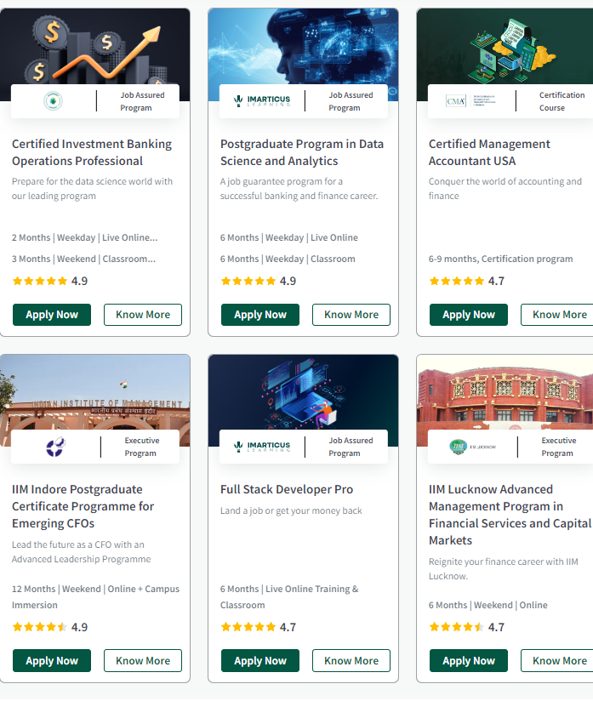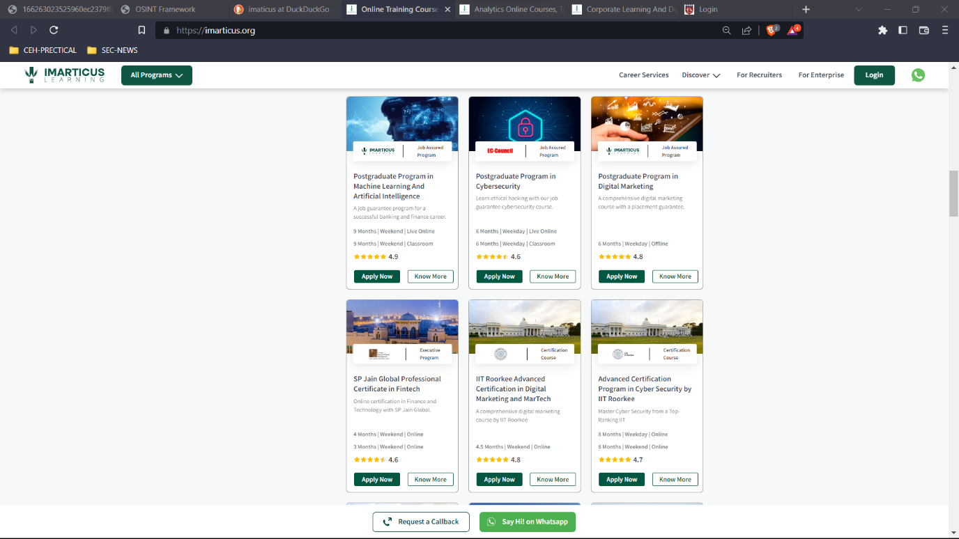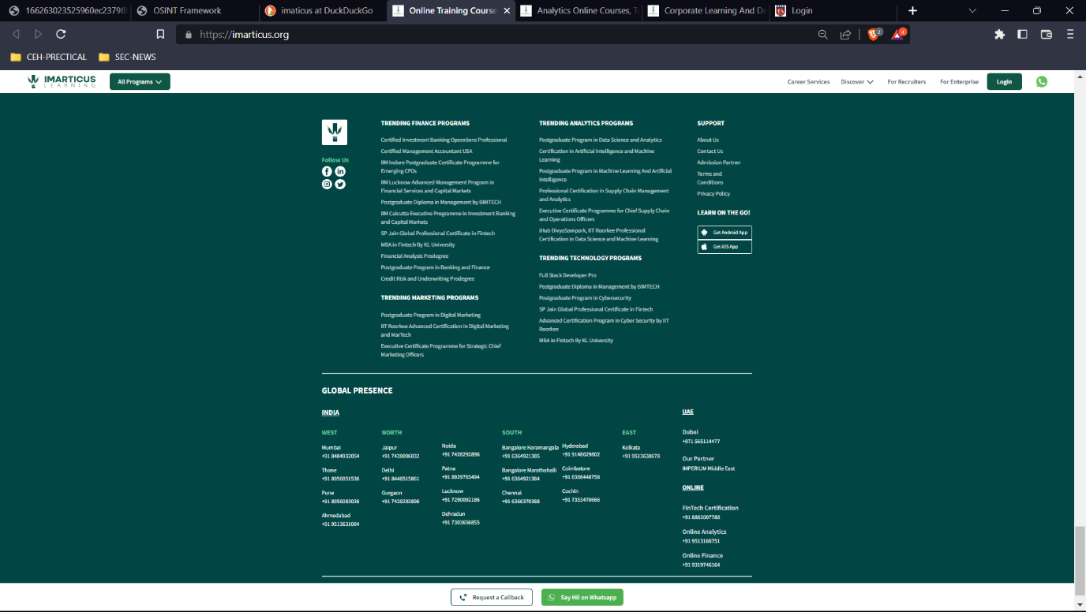

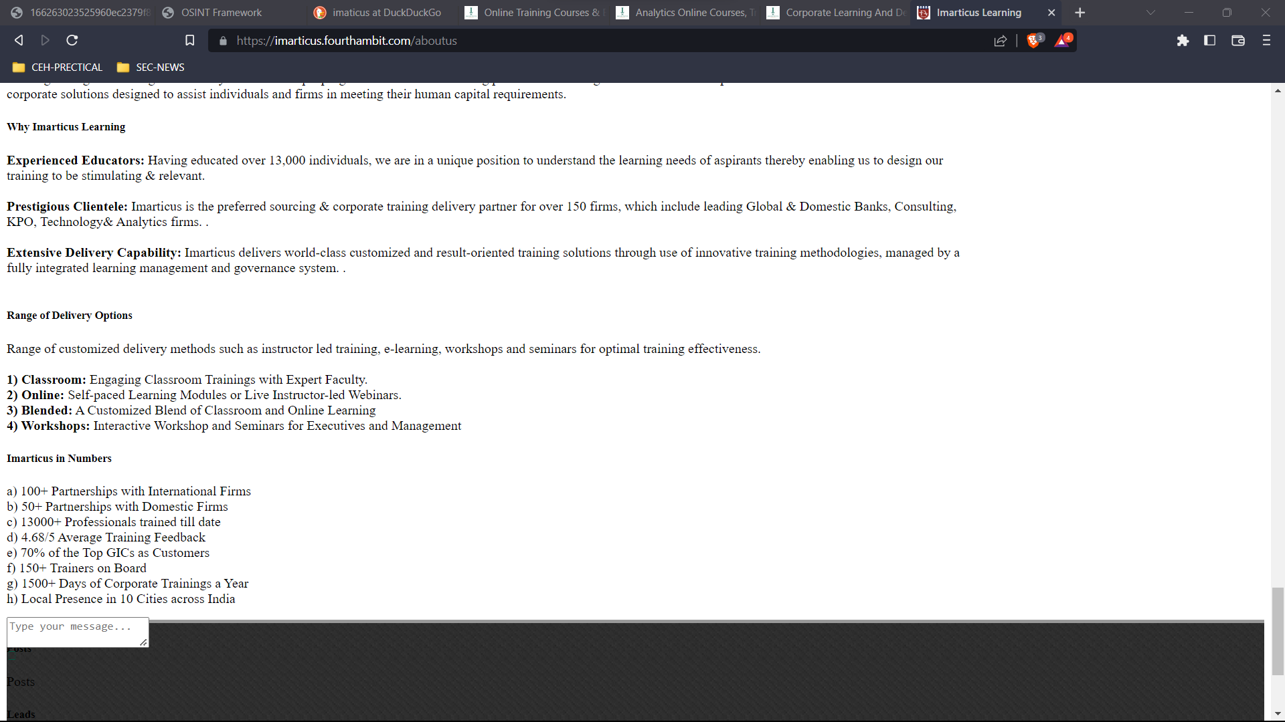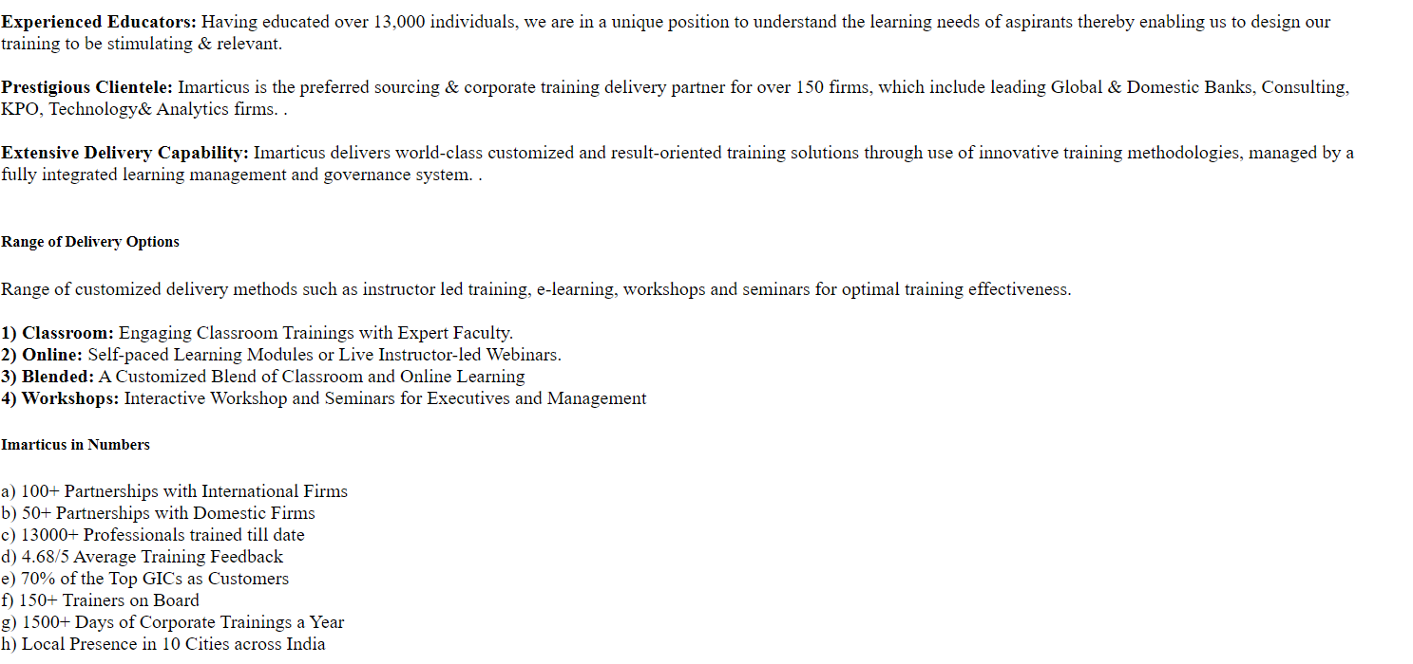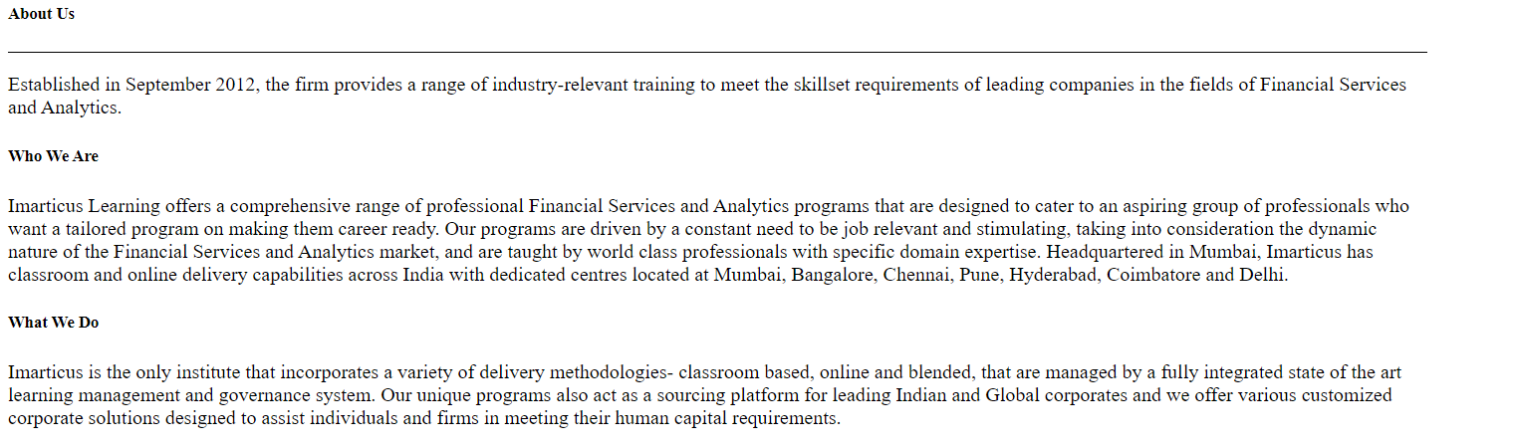

Through the official website’s of organizations we get many confidential information . in here the organization is based on education so we get information such as ..

Types of courses

Rates & reviews

Placements numbers

Locations

Social media handlers

Contact details

Those are the similar details but this details perform a crucial role when its come to social engineering.

**● Gathering information through analyzing Public Records, Phone Search, Username Check, email, CV and Resume Search, and Creating a Sock Puppet.**

There is different types of tools and techniques available for gathering information like username,email,phone.

Some are the tools are listed below:

Username:username and name information

<https://namechk.com/>

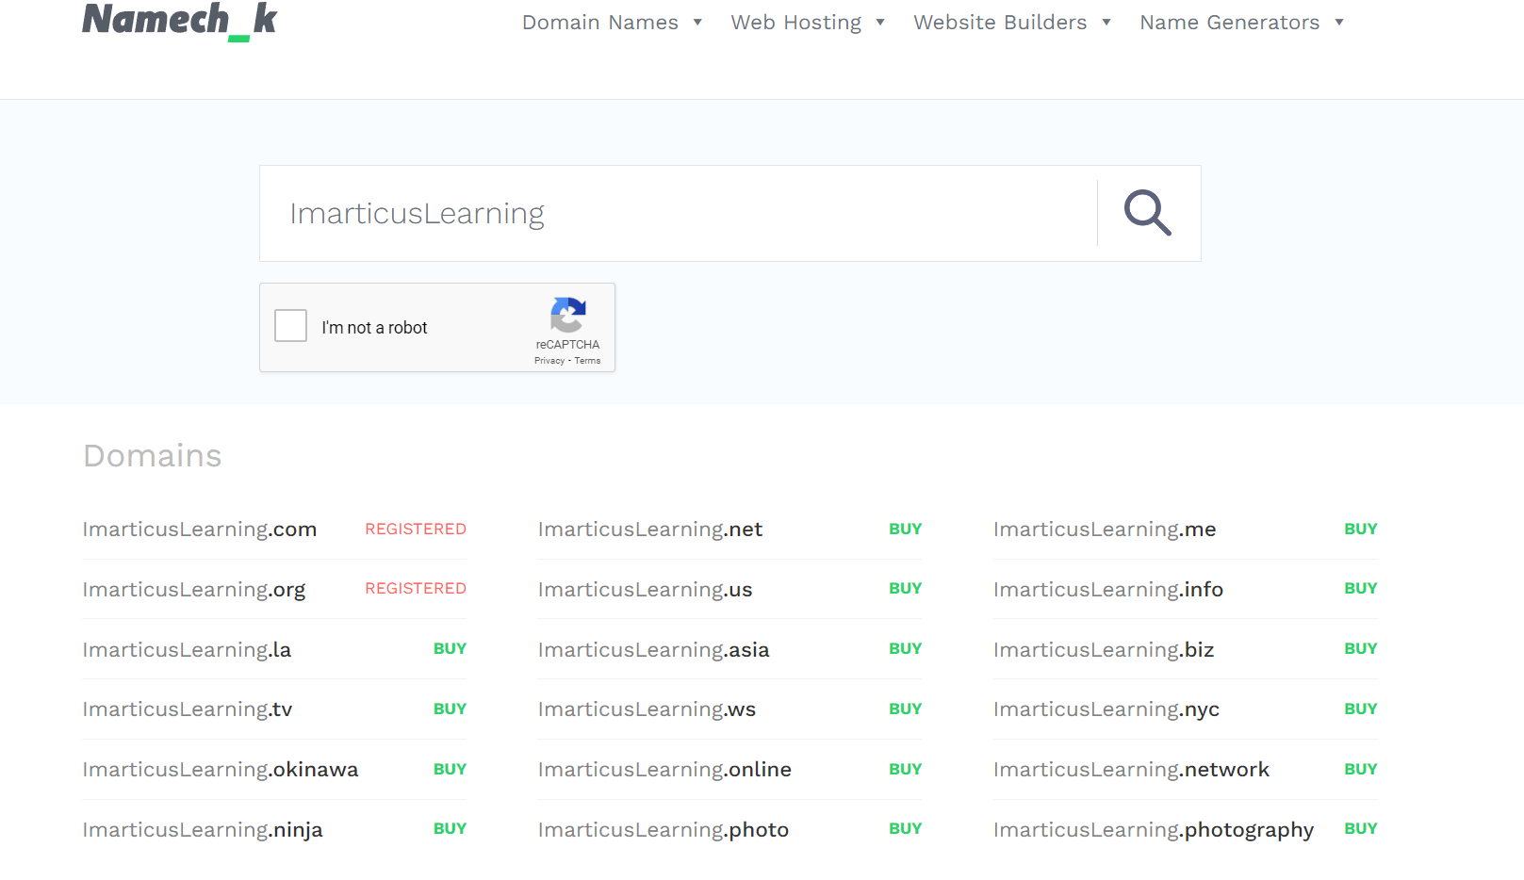

<https://instantusername.com/#/>

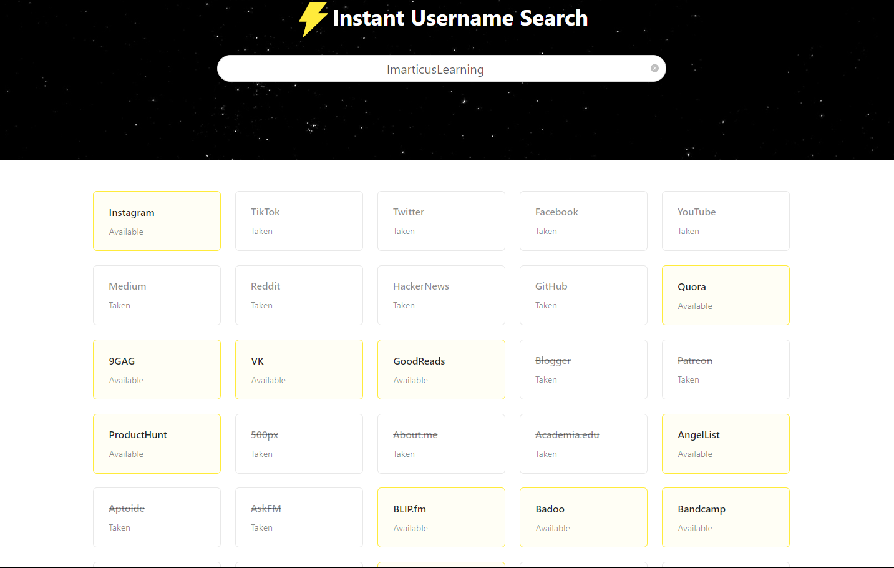

Phone numbers

Phoneinfoga :phone number information gathering

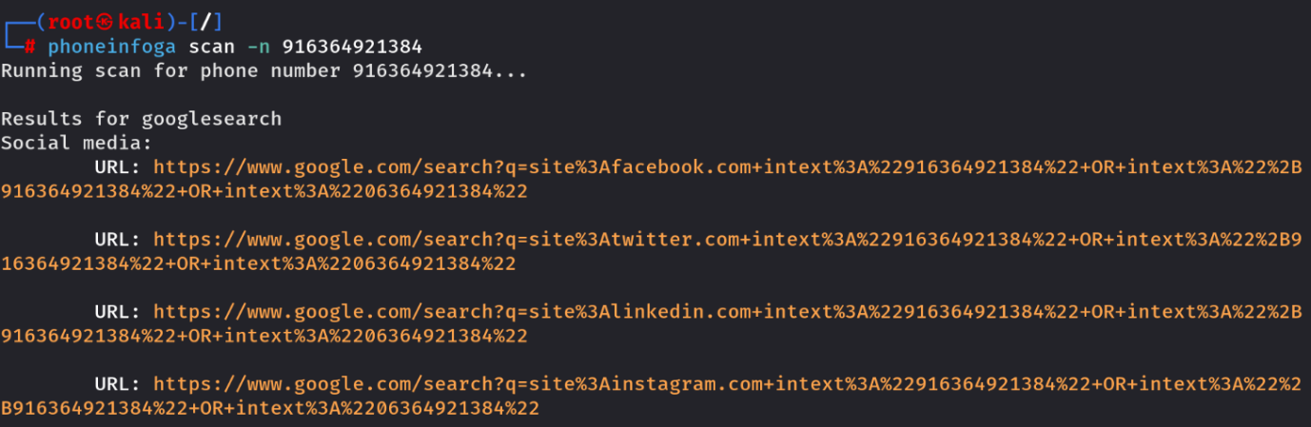

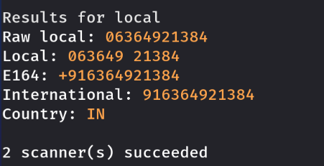

Phoneinfoga tool provides detail information about phone numbers which we can see in above images

Emails:email informations

Theharvester: email gathering

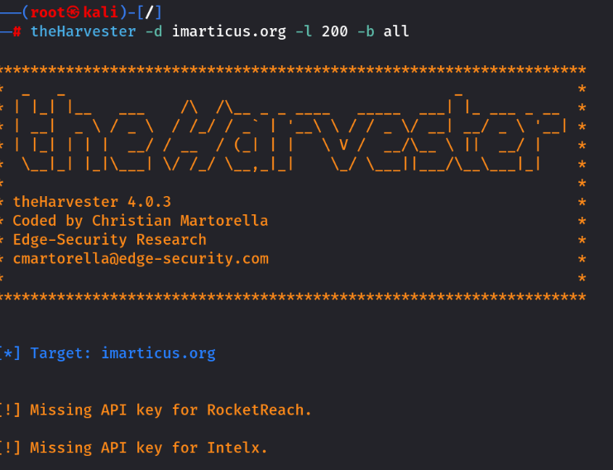

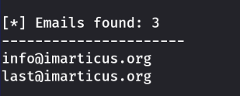

Here is we get the email address of organization ,we get more information with using this tools like emails,social media profiles,domains etc

**Sock Puppet:**

sock puppet is used for hiding the original identity.

<https://www.fakenamegenerator.com/>

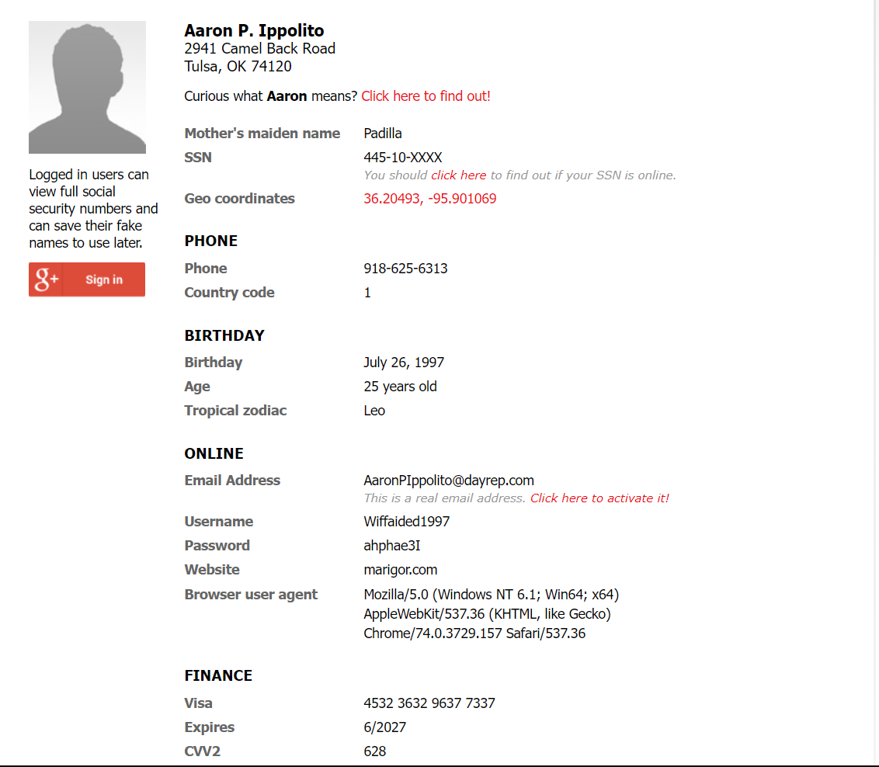

We can see that we created a random and fake id.

**● gather information like Business Registers details, Job Search Resources, Company Reviews, company existence on the internet, etc.**

**Business details:**

Type of business:Private

Industry:Online education, Online training, e learning

Products:Classroom Training, Online Certification, Online Training

Launched:July 2012

Current status:Online

Imarticus funding:

[**https://inc42.com/flash-feed/imarticus-funding/**](https://inc42.com/flash-feed/imarticus-funding/)

[**https://economictimes.indiatimes.com/small-biz/money/edutech-firm-imarticus-is-scouting-for-rs-35-crore/articleshow/59362881.cms**](https://economictimes.indiatimes.com/small-biz/money/edutech-firm-imarticus-is-scouting-for-rs-35-crore/articleshow/59362881.cms)

**Partnerships**

Imarticus has partnered with leading firms such as Genpact, EY, IBM, MCX, Motilal Oswal, Rise Mumbai to launch the industry led certifications. Imarticus is also the preferred sourcing, training and skill development partner for over 120 firms, which include leading Global & Domestic Banks, Consulting, KPO’s, Technology & Analytics firms. Some of these clients include Goldman Sachs, BNP Paribas, Societe Generale, Infosys, HSBC, KPMG, Accenture, HDFC Bank to name a few.

**Accreditation**

Imarticus is a Chartered Institute for Securities and Investments (CISI) and International Institute of Business Analysis (IIBA) accredited training provider. Imarticus also has an alliance with National Stock Exchange, MCX (Metal and Energy Trade with Trust) and NSDC (National Skill Development Corporation in india

**Reviews:**

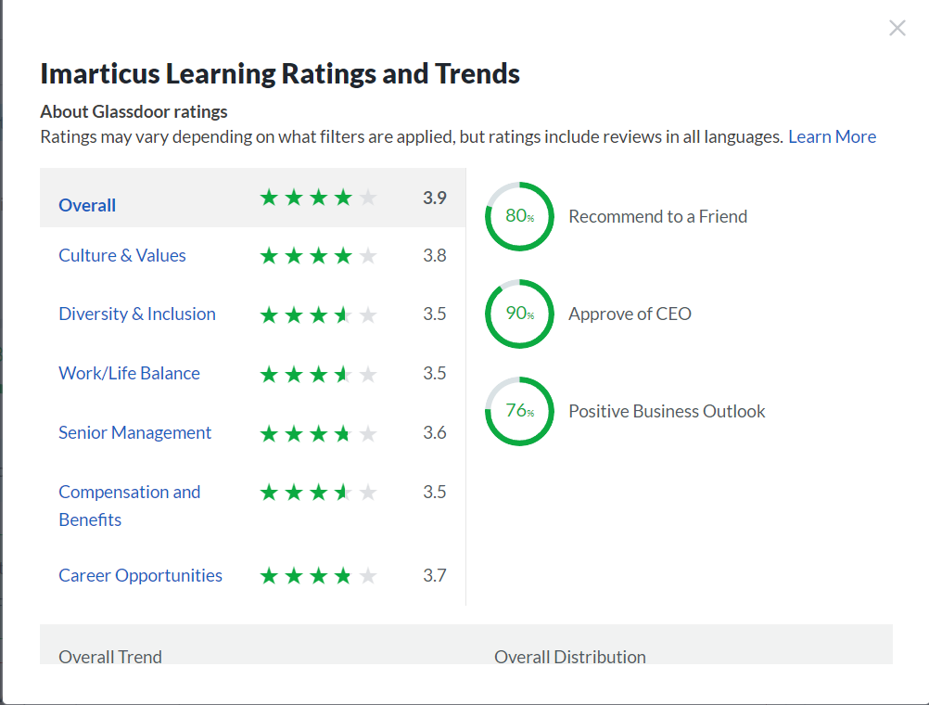

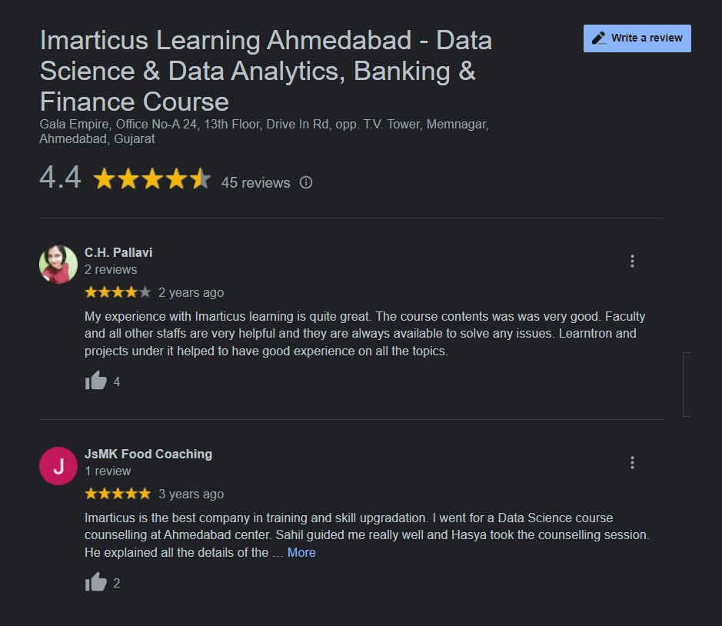

**Jobs search results:**

**Linkdein:**

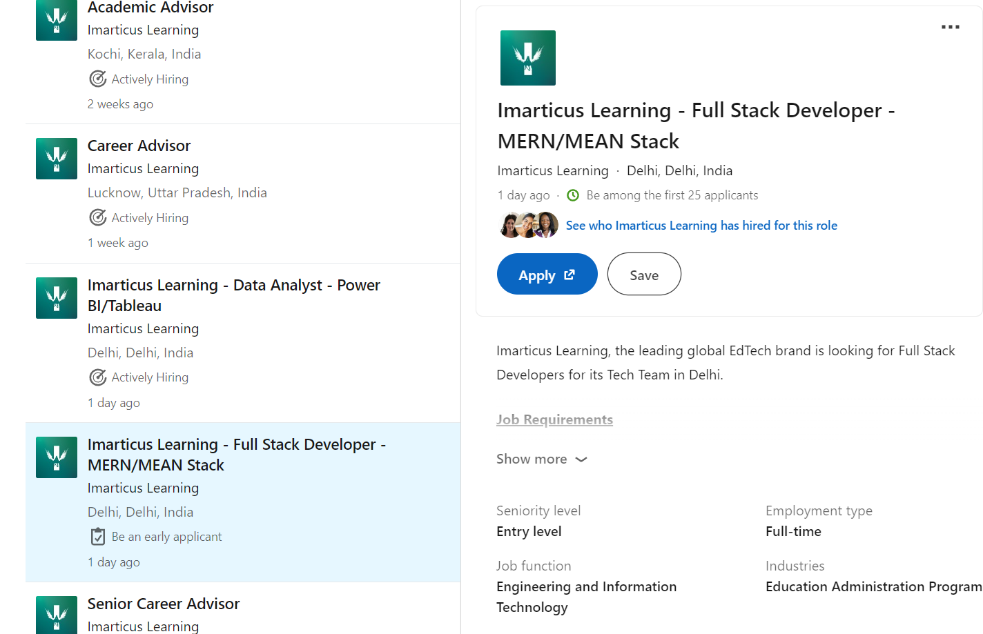

**● collect information from Classifieds and Online Marketplaces.**

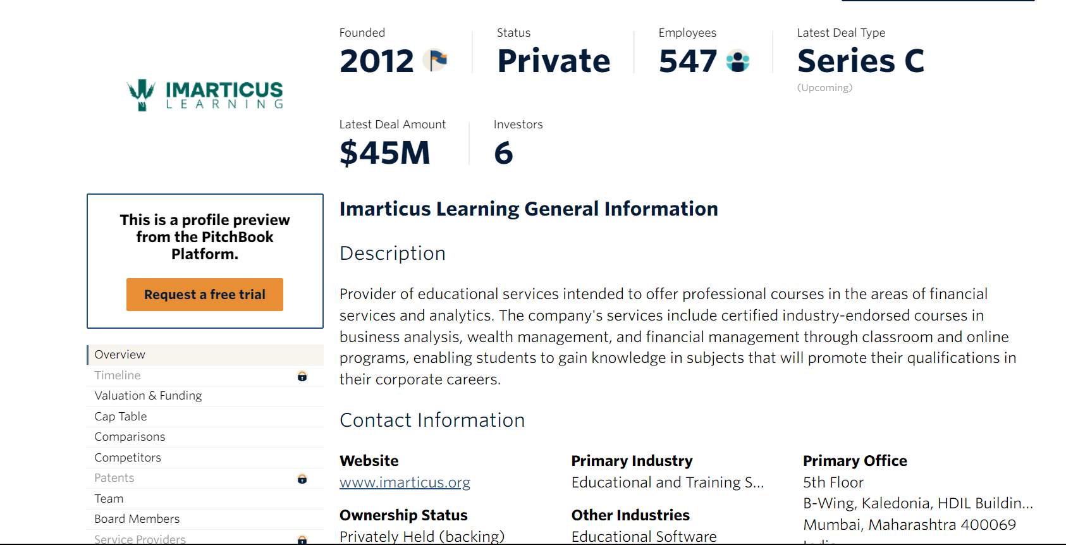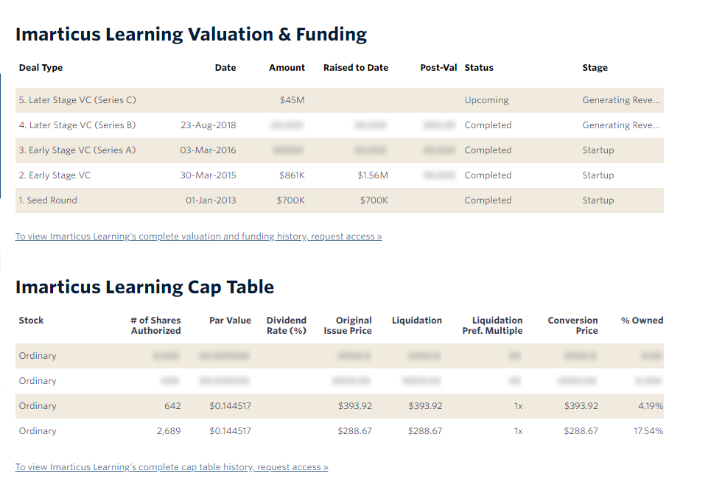

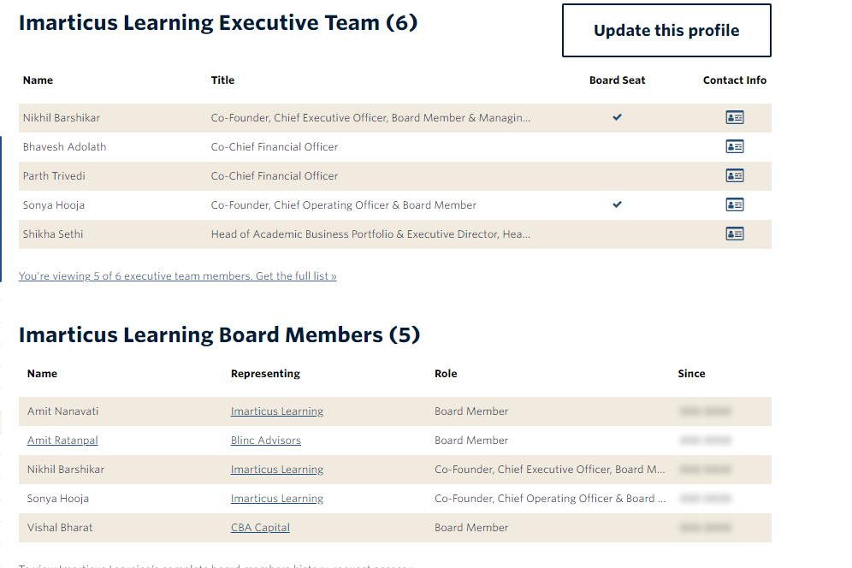

Here we have the financial and marketplace details of the organizations .

**● Collect information about Domain and IP Research, Websites Analysis, Web History, and Website Capture, Wifi Search, and Researching Dark Web.**

**Domain and Ip**

Ip search:

Simple way to identify ip of website is ping the web

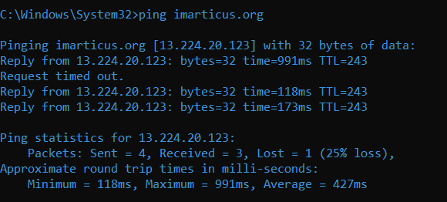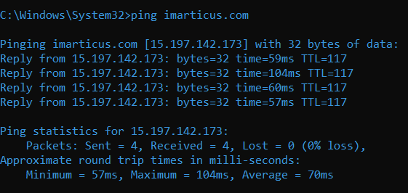

**Domains:**

There are many ways and tools to retrieve information about domain but in this we are going with simple information using <https://urlscan.io/> and <https://sitereport.netcraft.com/>

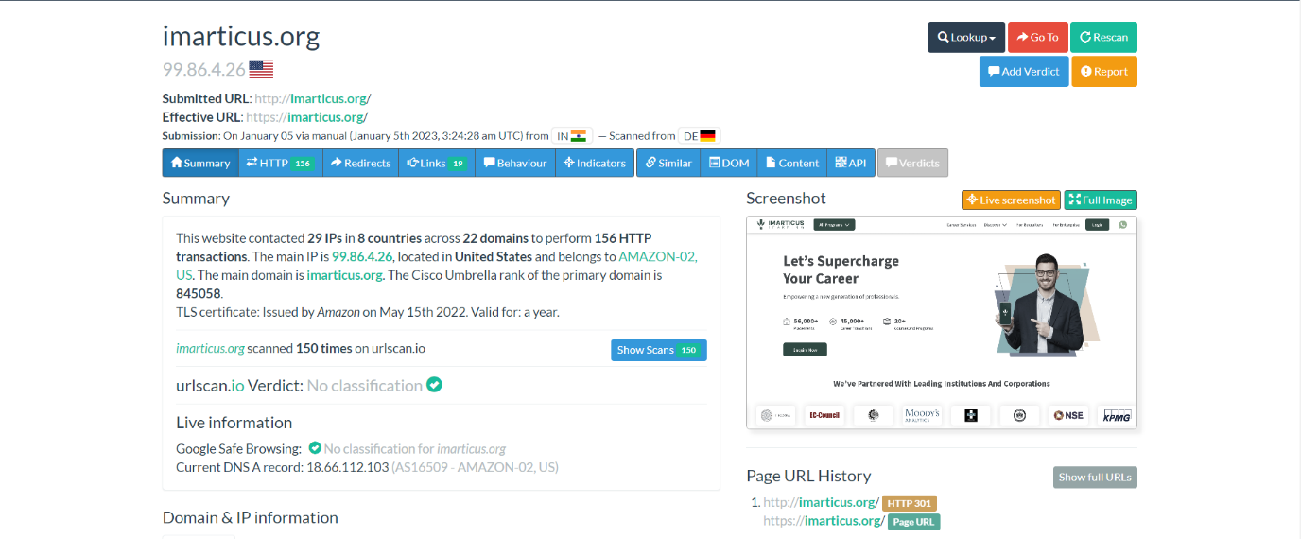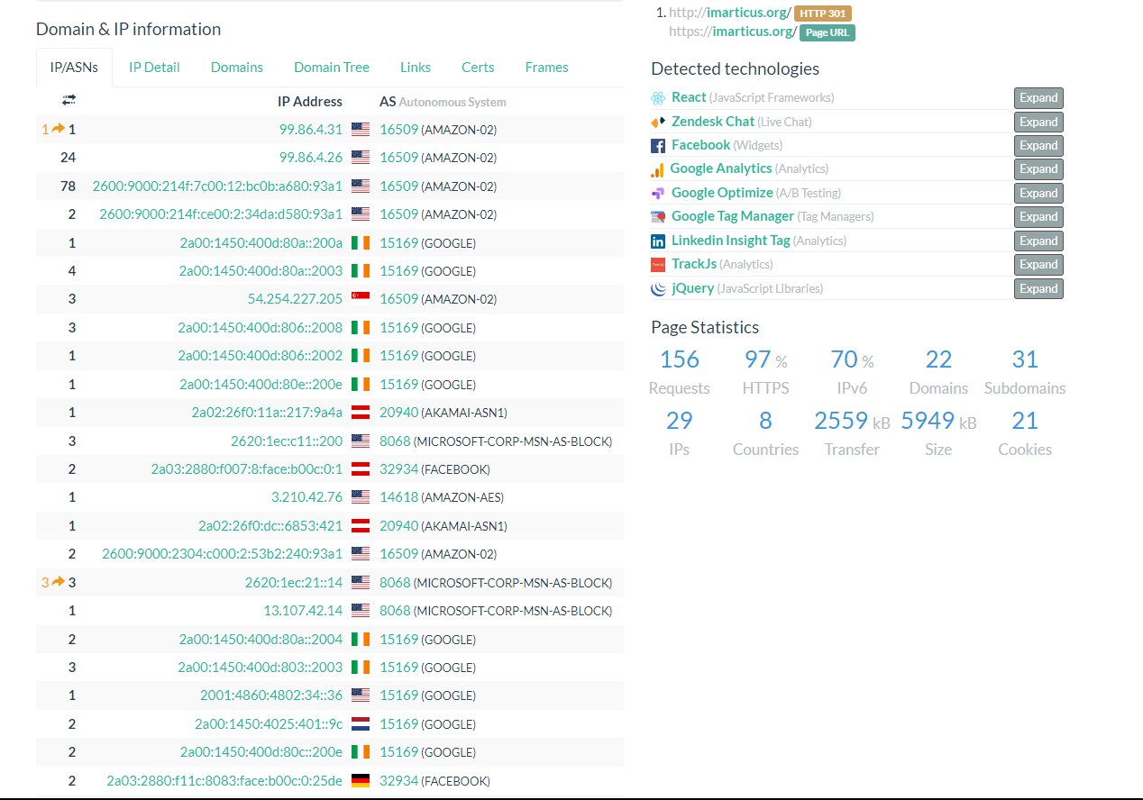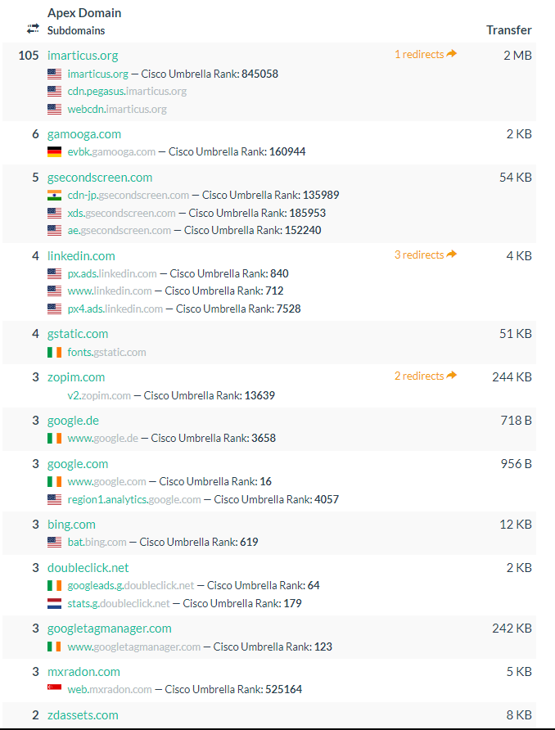

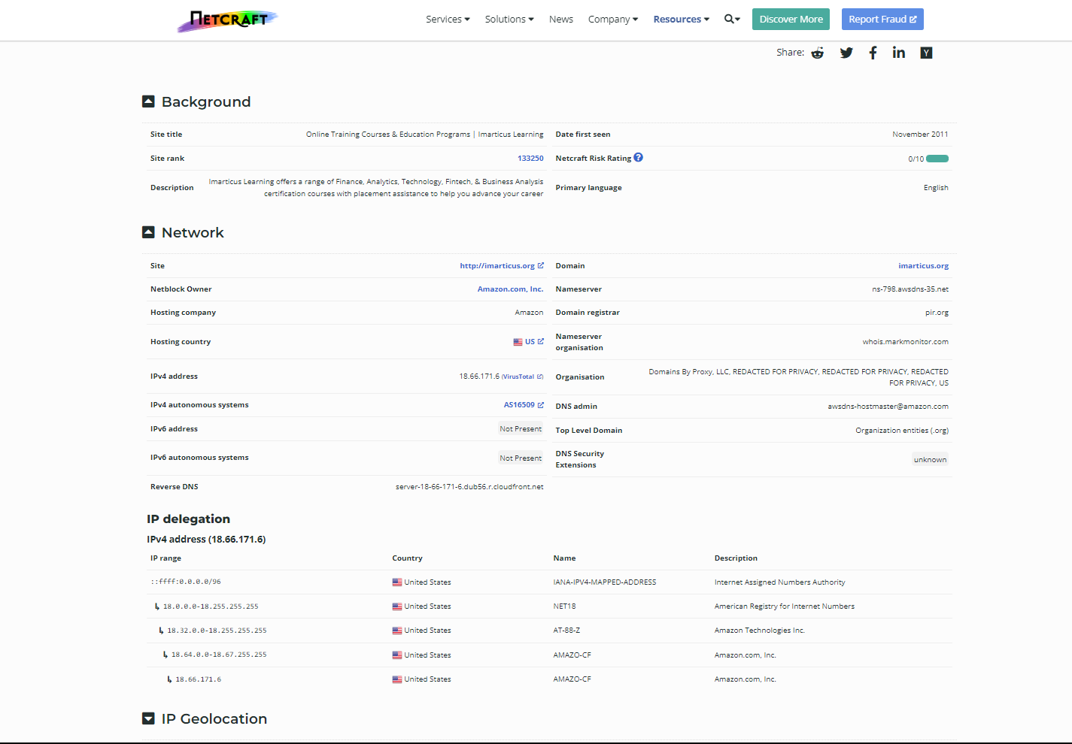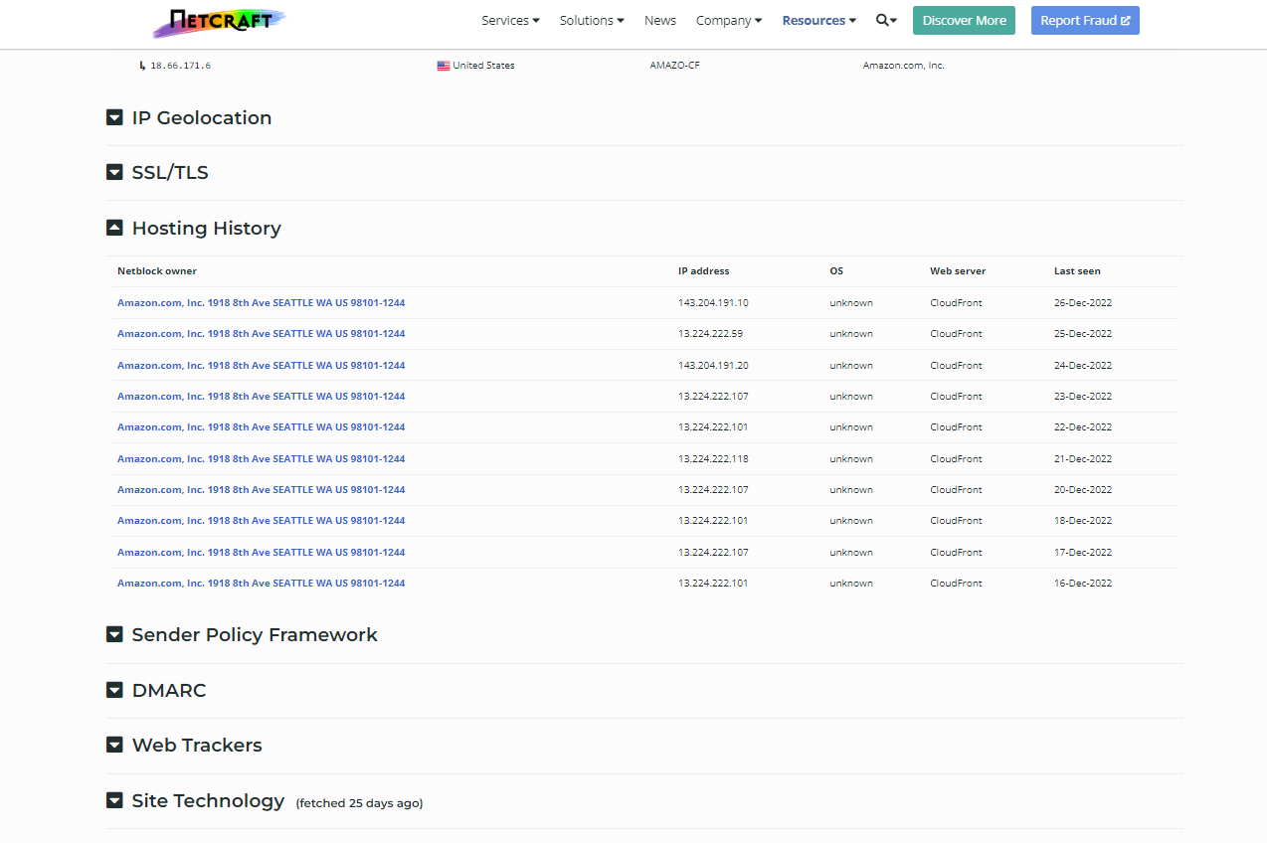

**Web History**

We can get the whole web history like at which year and date how it is look like and updates etc..

Waybackmachine:

<https://web.archive.org/>

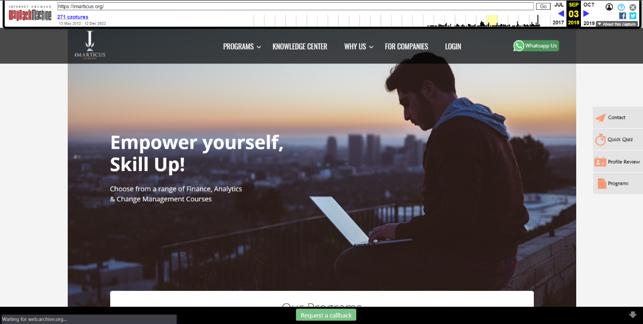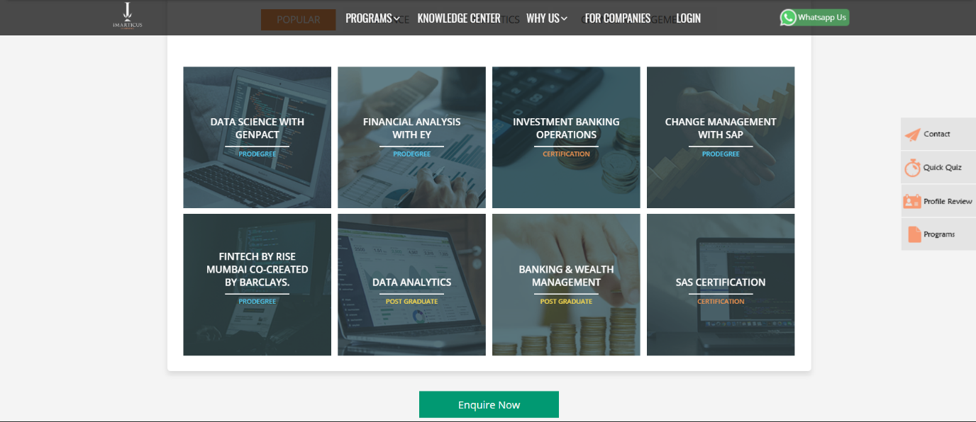

This is what organization website look like in sep,2018.

**● work with the images to do Image Search and Reverse Image Search, Image Analysis, OCR Tools, and retrieving metadata and geospatial data assumptions**

**Image search and Reverse Image Search:**

<https://images.search.yahoo.com/>

<https://images.google.com/>

<https://yandex.com/images/>

Through this search engines we can get the images according to our need

We can perform reverse image search using browser extensions

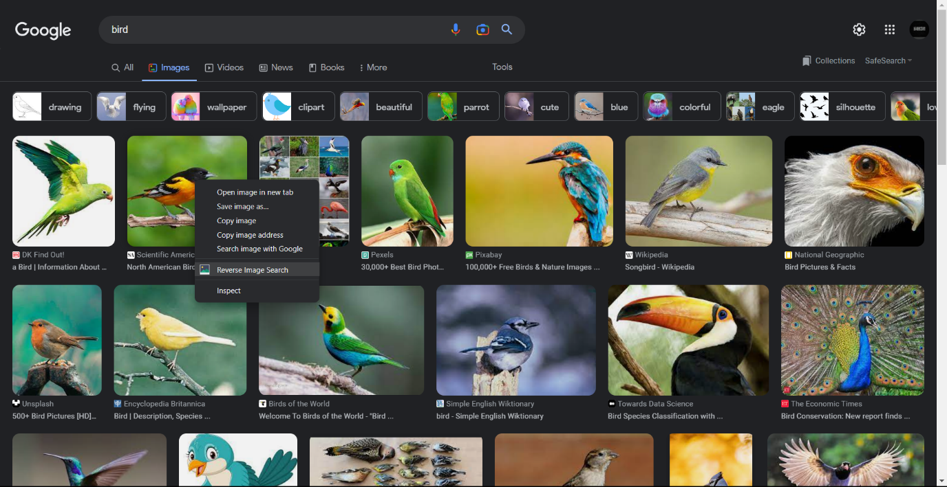

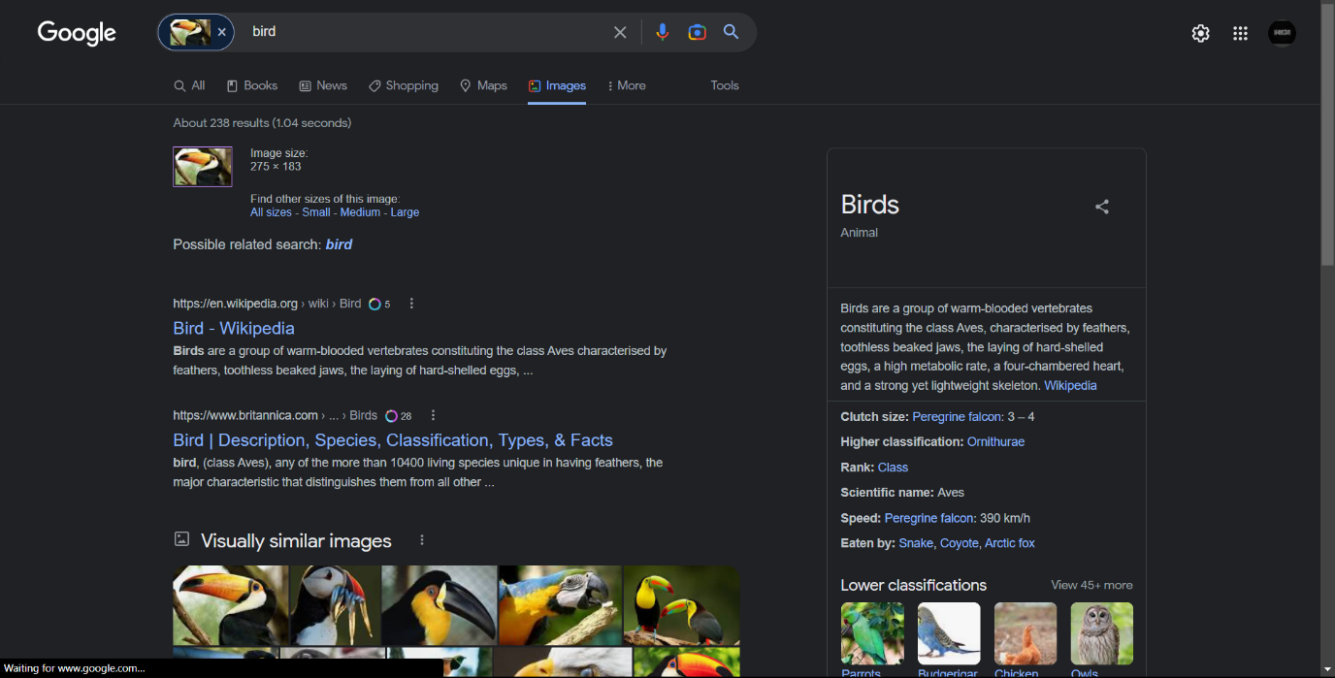

**Metadata:**

we can use different types of tools for gathering meta deta of image ,videos and pdf etc..

Here we are using the exiftool for gathering meta deta of a image

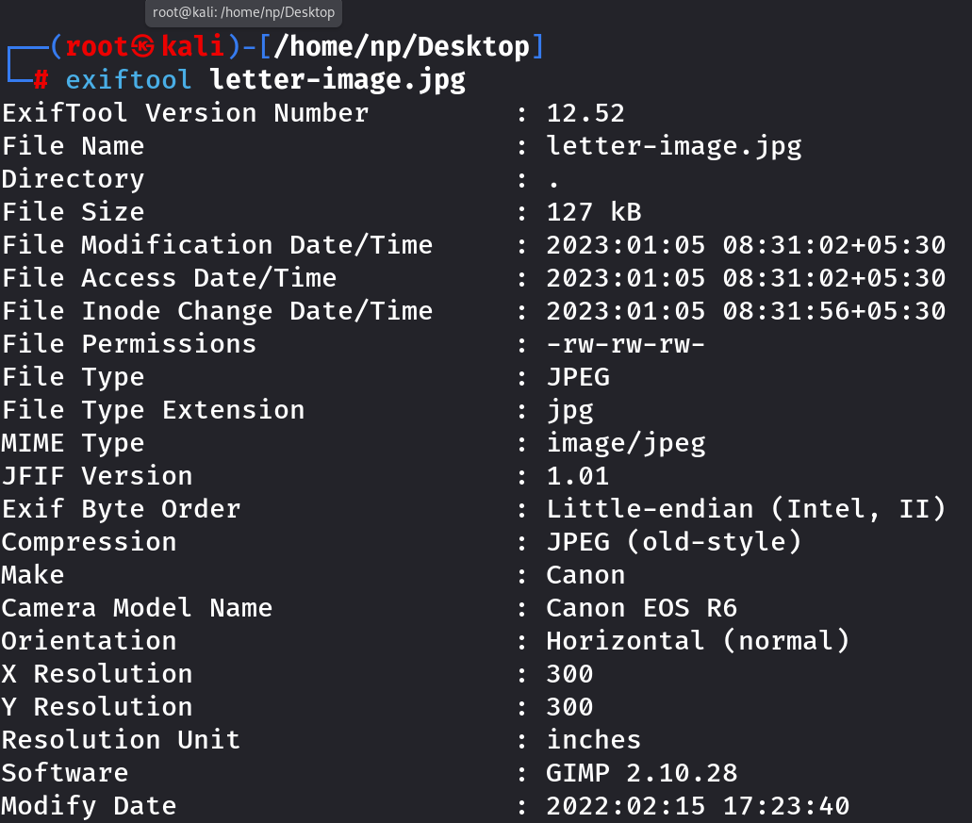

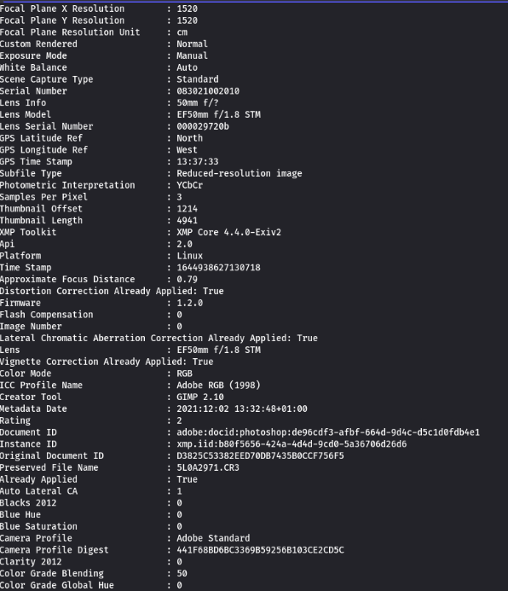

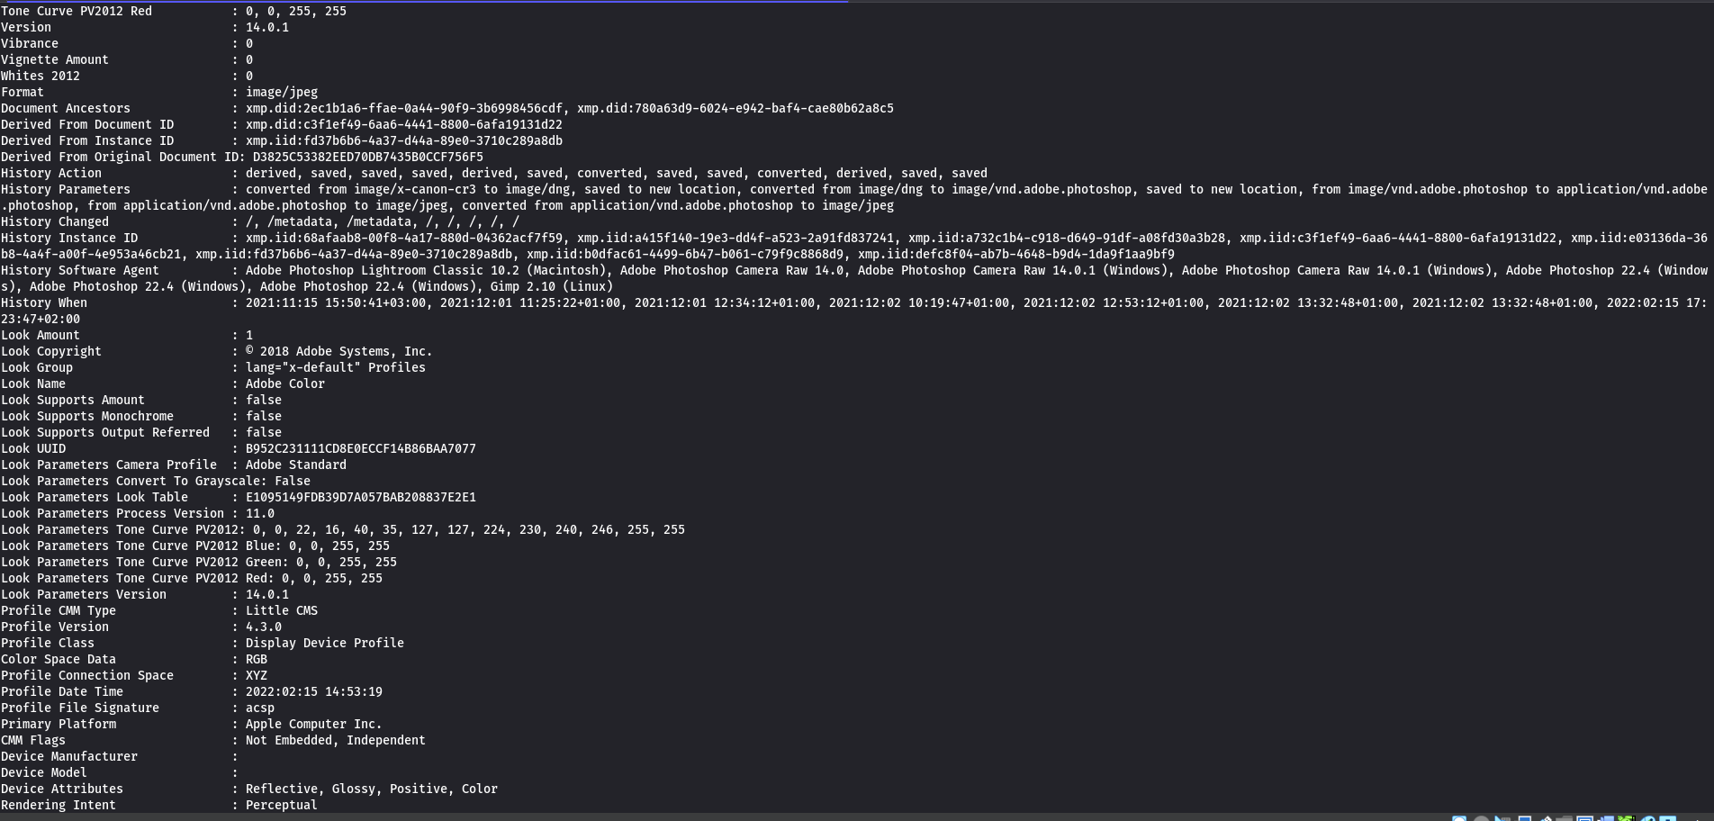

**Ocr tools:**

[**https://www.newocr.com/**](https://www.newocr.com/)

[**https://www.sodapdf.com/**](https://www.sodapdf.com/)

[**https://www.i2ocr.com/**](https://www.i2ocr.com/)

Gathering information using ocr tools

Result of image ocr:

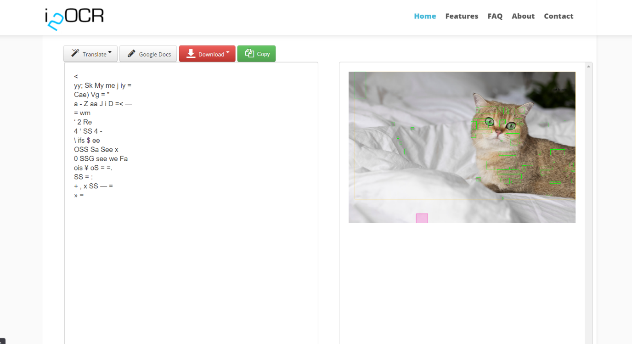

Result of pdf ocr:

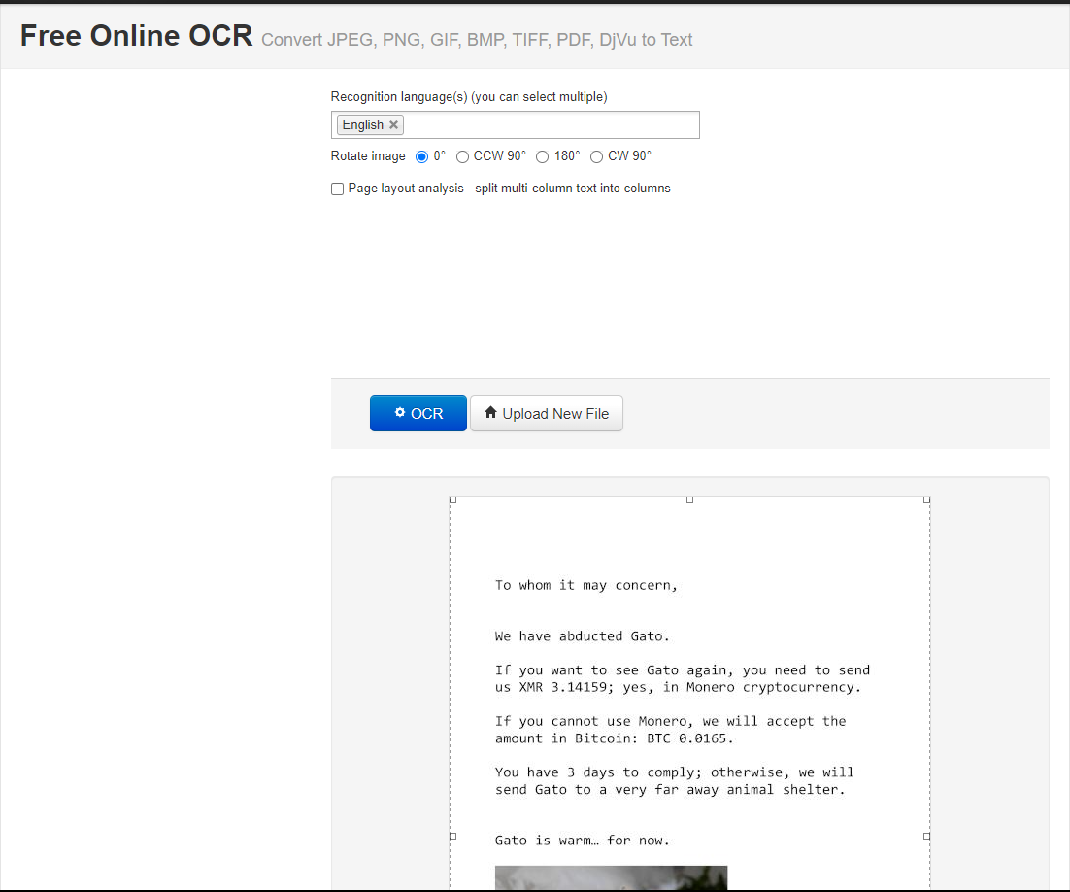

**● Working with Videos to perform Video Search and Reverse Video Search, Live Streaming Webcams, and Other Video Tools.**

search engines for videos

<https://www.google.com/videohp>

**metadata for videos:**

<https://mattw.io/youtube-metadata/>

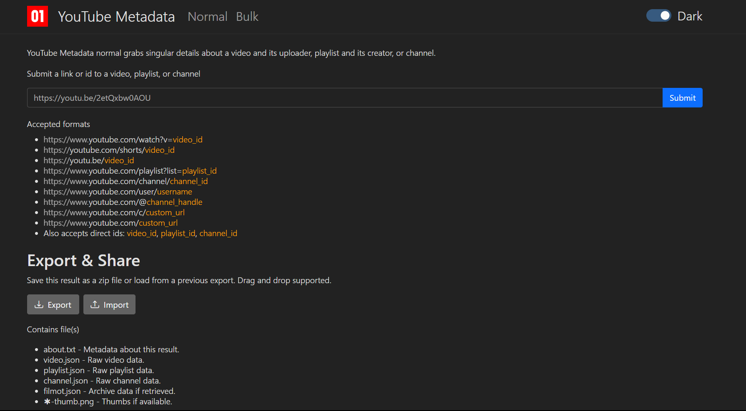

**●Collect information from documents, and browsers, and convert everything into the mindmap**